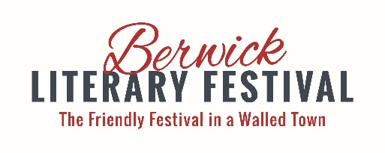

www.berwickliteraryfestival.com
info@berwickliteraryfestival.com
Charity number 1168860
WOULD YOU BE A PATRON?

The Berwick Literary Festival (first held in 2014) is an established part of the town’s cultural life, taking place each October. The Festival promotes the written and spoken word in all forms, through an extensive free programme of work in all the town’s schools; by a schools’ short story competition and poetry reading in care homes; and through a four-day schedule of talks and workshops by well-known authors and speakers. It is also one of the few literary festivals that makes a feature of poetry.

The pandemic meant that we had to move to an online festival in 2020, which was a great success, drawing large audiences from far beyond our usual hinterland. More information and a flavour of previous Festivals can be seen on our website, where there are links to our YouTube channel that hosts recordings of the majority of talks given in 2020.

The financial support of our Patrons is crucial in enabling the Festival to run. It is a charity and attracts grants and sponsorship but it is run by volunteers and is deliberately not profit-making. There is no college or museum in Berwick to support it, unlike Carlisle or Durham. We seek to recruit new Patrons to help provide the core income upon which the Festival depends. The cost is £25 (more if you wish!) per individual Patron and your name would normally be included in the Festival’s website and programme.

There are Patrons-only talks throughout the year and if possible a summer social event to launch the programme. Should there be live events Patrons will have priority booking and all Patrons are offered two free tickets for one of the talks for which there is a charge and receive a discount on a weekend pass.

I very much hope that you can support the Festival by becoming a Patron: if so, please contact me by e-mail or using the reply slip below, and I will look forward to welcoming you at events. Thank you.

Michael Gallico, Chair, BLF Steering Group, 72 Ravensdowne, Berwick-upon-Tweed TD15 1DQ
patrons@berwickliteraryfestival.com
______________________________________________________________________________________

I/we would like to become a Patron(s) of the Berwick Literary Festival. I/we enclose a cheque or cash for £25 per person (£ …….) payable to ‘Berwick Literary Festival’ (or pay TSB 77-20-05 a/c 04563368).

Name(s): ____________________________________________________________

Address: ____________________________________________________________

E-mail: ____________________________________________________________

I/we are/are not willing to have my/our name(s) included in the Festival website and printed programme.

The Festival is a registered charity and can reclaim income tax on your donation through Gift Aid. If appropriate we would be grateful if you could sign this declaration: I wish to Gift Aid my donation and any future donations I make. I am a UK taxpayer and understand that if I pay less income or capital gains tax in the current tax year than the amount of Gift Aid claimed on all my donations it is my responsibility to pay any difference.

Signed: ___________________________________________________ Date: ___________________

