Exhibition
Animals out of Place
Since unearthing 700 photographic glass slides depicting animals in Regent’s Park Zoo (circa 1910) in Suffolk Barbara Griffin and Graham Jarritt have toured an exhibition with a selection of the photographs. The display is comprised of light boxes with slides and images of animals accompanied by poems by Anna Edgar and Kathryn Hobson.
Website: https://barbaralgriffin3.wixsite.com/work
. 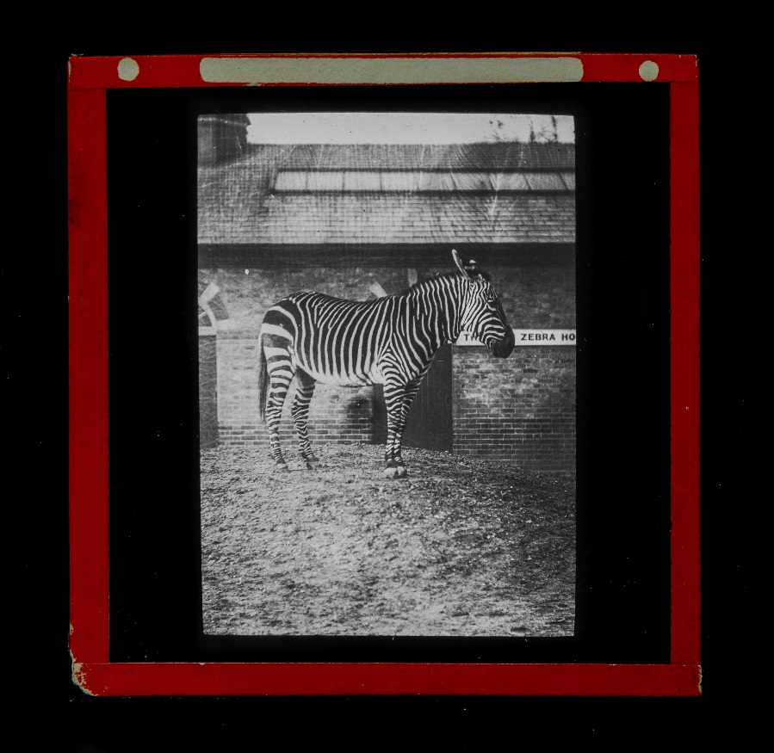
Photo Credit: Jason Hynes
Come along, be inspired and perhaps write your own poem!
St. Aidan’s Arts and Music Foundation
(formerly St. Aidan’s Peace Church)
10.00am to 4.00pm
Friday 18th to Sunday 20th October
Admission Free

